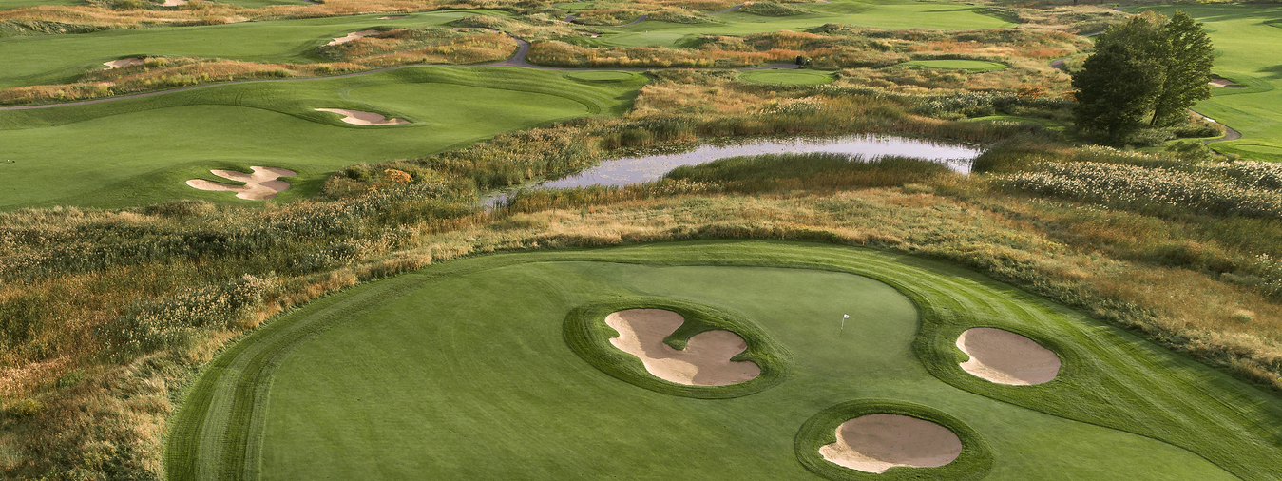
Shenandoah Golf Course – Turning Stone Resort & Casino
The Ninth District Dental Association Golf Tournament

May 30, 2024

Please select the Sponsorship Package you would like to purchase. Thank you for supporting our golf event
Exclusive Dinner Sponsor $5,000.00
This package includes 4 golfers
We are offering only 1 of these sponsorships, it includes:
- Large Sign at the Banquet Dinner & CE Program
- Large Sign at the 18th tee box
- Ability to address participants during the dinner for up to 5 minutes
- Special mention in the event program, with logo
- Logo and recognition on the event flyer and promotional material (if received by April, 1 2024)
- One golf foursome

Putting Contest Sponsor $500.00
- Only one of the sponsorships will be sold
- Sponsor the Putting Contest
- Signage at registration
- Signage at the putting contest
- Sponsor presence on putting green during contest
- Recognition in program
- Present prize at dinner
Hole-In-One Sponsor $850.00
- All golfers will have the opportunity to win $10,000.00 thanks to your sponsorship
- Signage at registration
- Signage at the Hole-In-One hole
- Recognition in the program
- Presence welcome at the Hole-In-One hole during the outing
Exclusive Lunch Sponsor $3,500.00
This package includes 4 golfers
We are offering only 1 of these sponsorships, it includes:
- Large sign at lunch recognizing your sponsorship and generosity
- Large Sign at the 1st tee box
- Special mention in the event program, with logo
- Logo and recognition on the event flyer (if received by April, 1 2024)
- One golf foursome
Shirt Sponsor $7,000.00
This package includes 4 golfers
- Sponsor logo on official tournament shirt
- Signage at registration
- One hole sign sponsorship
- Recognition in program
- One golf foursome
Tee Sign Sponsor $250.00
- Sponsor logo on sign prominently displayed at one of the holes on the course
- Recognition in program
- Great option for office or personal recognition of support
Random Club Closest To The Pin Sponsor $500.00
- Only one of these sponsorships will be sold
- Random Club Dice Roll
- Sponsor a Closest to The Pin Contest (Prize included in the sponsorship)
- Signage at registration
- Signage at the Closest to The Pin hole
- Recognition in program
- Present prize to winner at dinner
For information, please contact Dr. Stephen Ossen OR Stephan Cancian - Executive Director
(646) 645-5446 (c) (914) 747-1199
ossensteve@gmail.com stephan@ninthdistrict.org
Corporate Sponsor $1,600.00
This package includes 4 golfers
We are offering only 4 of these sponsorships, it includes:
- Signage at registration
- Sponsor logo on sign prominently displayed at one of the holes on the course
- Recognition lunch and dinner
- Recognition in program
- One golf foursome
- GREAT OPTION FOR A DENTAL OFFICE SPONSORSHIP AS WELL – CAN BRING STAFF MEMBERS TO JOIN YOU
Closest To The Pin Sponsor $500.00
- Only one of these sponsorships will be sold
- Sponsor a Closest to The Pin Contest (Range Finder included in the sponsorship)
- Signage at registration
- Signage at the Closest to The Pin hole
- Recognition in program
- Present prize to winner at dinner
Long Drive Sponsor $500.00
- Sponsor a Long Drive contest
- Signage at registration
- Signage at the Long Drive hole
- Recognition in program
- Present prize to winner at dinner

